July 24, 2020

IMPORTANT INFORMATION REGARDING YOUR ATM OR DEBIT CARD

Dear Valued Customer:

As a continuation of our computer systems upgrade last summer, The Bank of Charlotte County is converting its ATM and Debit Cards to the new system on August 24, 2020.

Your ATM or Debit Card account number will not be changed, and your card will not be re-issued. Keep your current card and use it exactly as you do now. Debit Cardholders will continue to use their current PIN; however, ATM Cardholders must change their PIN once the conversion is complete.

The weekend before conversion, both ATM and Debit Cards will have limited withdrawal amounts and some limited functionality, so please plan accordingly.

Additionally, our ATMs will no longer accept deposits. You may make deposits at our branch offices or via our Mobile Banking service. If you are not currently using Mobile Banking, instructions are available on our website under the E-Banking tab.

See the Questions and Answers on the back of this letter for greater details about using your ATM and Debit Cards as they transition to the new computer system. This information will also be posted on our website at www.bankofcharlotte.com for your convenience. Our bankers are ready to answer any additional questions you may have…just contact your nearest branch. And, as always, we appreciate YOU…our customer!

Sincerely,

Electronic Banking Department

ATM and Debit Card Questions and Answers

Q. CAN I USE MY CURRENT MASTERCARD ATM/DEBIT CARD? | - Yes, ATM and Mastercard Debit Cards will not be replaced, so your current card(s) will continue with the same functionality and limits.
Q. CAN I USE MY CURRENT PIN? | - Debit Card PINs will remain the same; however, ATM Card PINs must be changed after conversion.
Q. HOW DO I CHANGE THE PIN FOR MY ATM CARD? | - Beginning at 9:00 AM on Monday, August 24, 2020, call 1-800-290-7893 and follow the instructions to change your PIN.
Q. WILL THE BANK’S ATMs BE UNAVAILABLE AT ANY TIME? | - Our ATMs will be available throughout the weekend before the 8/24/2020 conversion. However, from 3:00 PM on Friday, August 21, through 6:00 AM on Monday, August 24, balance inquiry, transfer, and deposit functions will not be available.
Q. WHAT WILL THE WITHDRAWAL LIMITS BE DURING THE WEEKEND BEFORE CONVERSION? | - From 3:00 PM on Friday, August 21, through 6:00 AM on Monday, August 24, ATM withdrawals and Point-of-Sale purchases will be limited to:  ATM Cards -- $305 total ATM withdrawals and fees per day.  Consumer Debit Cards -- $305 total ATM withdrawals and fees per day, and $500 total Point-of-Sale purchases per day  Business Debit Cards -- $505 total ATM withdrawals and fees per day, and $1,250 total Point-of-Sale purchases per day
Q. WHEN WILL NORMAL WITHDRAWAL LIMITS BE RESTORED? | - Once the conversion has been finalized at approximately 6:00 AM on Monday, August 24, 2020, normal withdrawal limits will be restored.
Q. CAN I CONTINUE TO USE THE BANK of CHARLOTTE COUNTY ATMs AT NO CHARGE? | - Yes, you will be able to continue using the bank’s ATMs at no charge throughout the conversion weekend and forward. The bank does charge a $1.00 fee for using your ATM/debit card at another bank/provider, and remember that you may also incur an additional fee by the other bank/provider.
Q. CAN I CONTINUE TO MAKE DEPOSITS AT THE BANKS ATMs? | - No, ATMs will no longer accept deposits after the conversion on August 24, 2020. Deposits can be made at our branches or via our Mobile Deposit service.
Q. HOW CAN I IDENTIFY MY CARD AS AN ATM OR DEBIT CARD? | - An ATM Card is beige, a Consumer Debit Card is blue, and a Business Debit Card is black. See the sample images below to assist in identifying which card you hold.
Q. IF I RECEIVED A NEW ATM OR DEBIT CARD AND DID NOT ACTIVATE IT BEFORE MONDAY, AUGUST 24, 2020, WHAT DO I DO? | - Just call 1-800-290-7893 any time after 9:00 AM on Monday, August 24, 2020, to activate the card.

SAMPLE ATM CARD | SAMPLE CONSUMER DEBIT CARD | SAMPLE BUSINESS DEBIT CARD
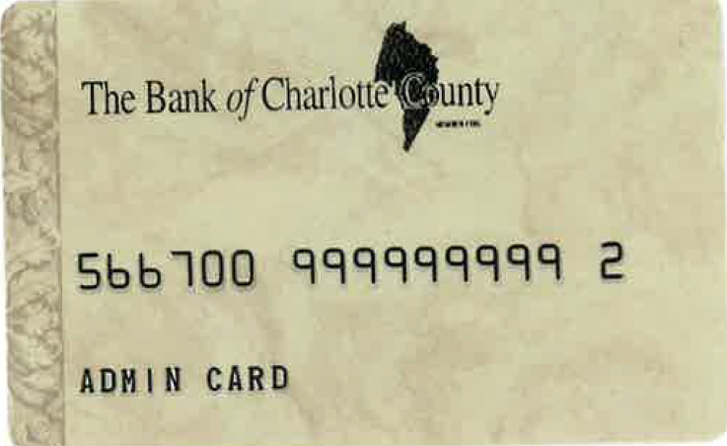  NAME | 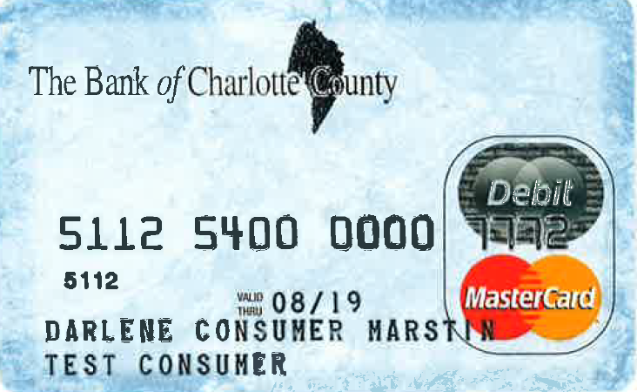  NAME | 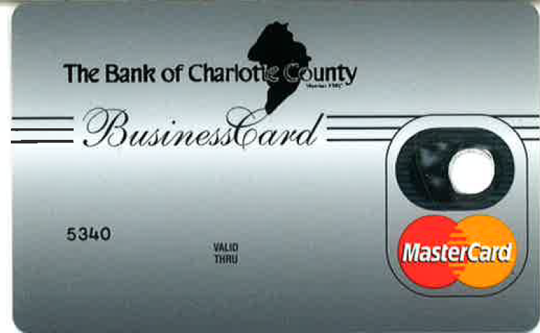  NAME

